Employee Expense management System
Objective:
Employee Expense management System is an online application to be built as a product that can be catering to various customers who requires purchasing books.
Users of the System:
- Admin
- Manager
- Employee
Functional Requirements:
- Voucher Entry – Screen for entering expense vouchers for any reimbursable expenses borne by the employee.
- A voucher should have one header and multiple lines providing detailed information of expenses incurred along with amounts.
- Accounts View – Accounts department users should be able to view approved vouchers of all employees and mark vouchers as paid. This step completes the lifecycle of the voucher and the associated process instance.

While the above ones are the basic functional features expected, the below ones can be nice to have add-on features:
- Email integration for intimating new person signup.
- Multi-factor authentication for the sign-in process
Output/ Post Condition:
- Records Persisted in Success & Failure Collections
- Standalone application / Deployed in an app Container

Non-Functional Requirements:

Security | - App Platform –UserName/Password-Based Credentials  - Sensitive data has to be categorized and stored in a secure manner  - Secure connection for transmission of any data
Performance | - Peak Load Performance  - Expence Management -< 3 Sec  - Admin application < 2 Sec  - Non Peak Load Performance
Availability | - 99.99 % Availability
Standard Features | - Scalability  - Maintainability  - Usability  - Availability  - Failover
Logging & Auditing | - The system should support logging(app/web/DB) & auditing at all levels
Monitoring | - Should be able to monitor via as-is enterprise monitoring tools
Cloud | - The Solution should be made Cloud-ready and should have a minimum impact when moving away to Cloud infrastructure
Browser Compatible | - IE 7+  - Mozilla Firefox Latest – 15  - Google Chrome Latest – 20  - Mobile Ready

Technology Stack
Front End | Angular 7+  Google Material Design  Bootstrap / Bulma
Server Side | Spring Boot  Spring Web (Rest Controller)  Spring Security  Spring AOP  Spring Hibernate
Core Platform | OpenJDK 11
Database | MySQL or H2

Platform Pre-requisites (Do’s and Don’ts):
- The angular app should run in port 8081. Do not run the angular app in the port: 4200.
- Spring boot app should run in port 8080.

Key points to remember:
- The id (for frontend) and attributes(backend) mentioned in the SRS should not be modified at any cost. Failing to do may fail test cases.
- Remember to check the screenshots provided with the SRS. Strictly adhere to id mapping and attribute mapping. Failing to do may fail test cases.
- Strictly adhere to the proper project scaffolding (Folder structure), coding conventions, method definitions and return types.
- Adhere strictly to the endpoints given below.

Application assumptions:
- The login page should be the first page rendered when the application loads.
- Manual routing should be restricted by using AuthGaurd by implementing the canActivate interface. For example, if the user enters as http://localhost:4200/signup or http://localhost:4200/home the page should not navigate to the corresponding page instead it should redirect to the login page.
- Unless logged into the system, the user cannot navigate to any other pages.
- Logging out must again redirect to the login page.
- To navigate to the admin side, you can store a user type as admin in the database with a username and password as admin.
- Use admin/admin as the username and password to navigate to the admin dashboard.

Validations:
- Basic email validation should be performed.
- Basic mobile validation should be performed.
Project Tasks:
API Endpoints:
USER
Action | URL | Method | Response
Login | /login | POST | true/false
Signup | /signup | POST | true/false
All Expense | /expense | GET | Array of expense
Expense Details | /expense /{id} | GET | Expense Detail by Id
Add Expense | /expense | POST | Expense Added
Update Expense | /expense/{id} | PUT | Expense Updated
MANAGER
Action | URL | Method | Response
Get All Expense | /manager | GET | Array of Expense
Update Expense | /manager/expense/{id} | PUT | Updated
Delete Expense | /manager/expense/{id} | DELETE | Expense deleted
Get Expense | /manager/expense/{id} | GET | Get All details of Particular id
ADMIN
Get All User | /admin | GET | Array of Expense
Get User | /admin/{id} | GET | User Details
Update User | /admin/user/{id} | PUT | Updated
Delete User | /admin/user/{id} | DELETE | Expense deleted

Frontend:
User:
Login:
Output Screenshot:
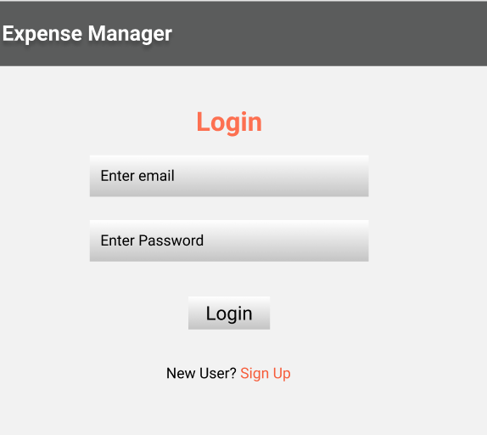
Signup:
Output Screenshot:
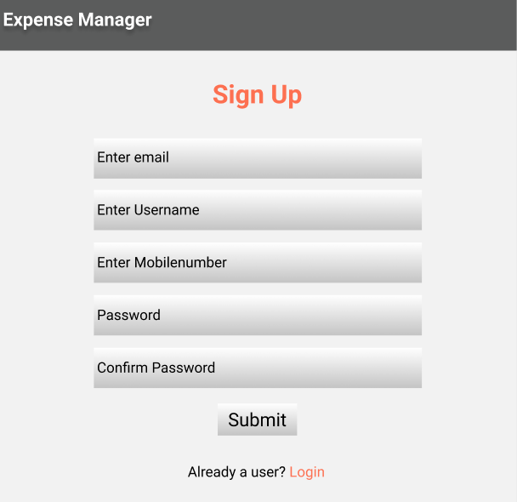
Home:
Output Screenshot:
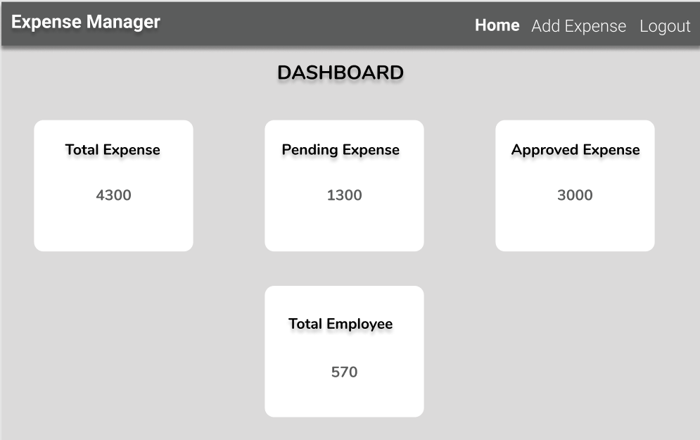
ADD Expense:
Output Screenshot:
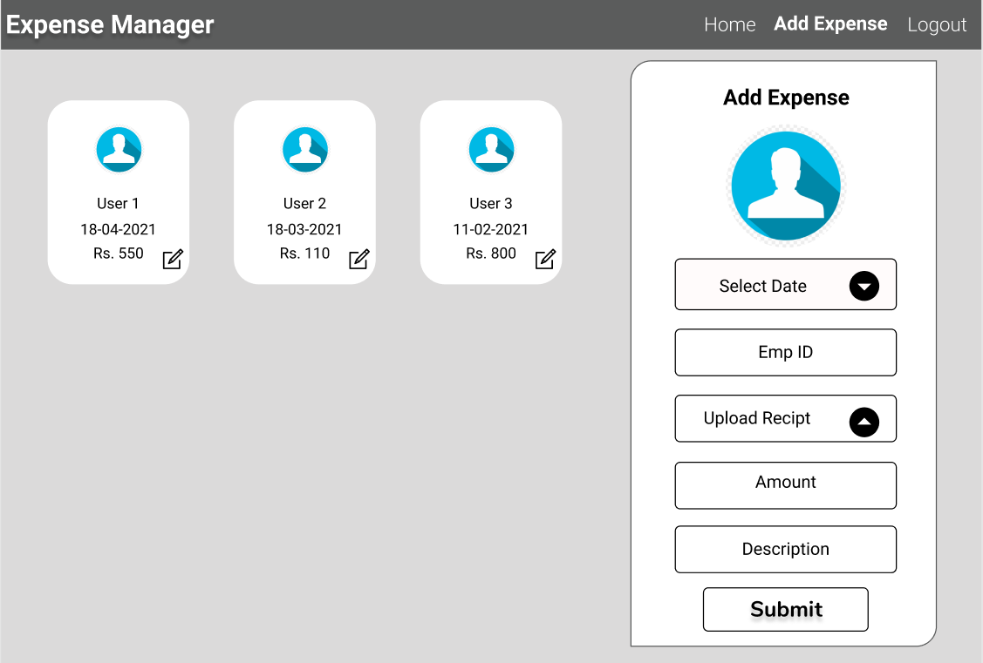
Manager:
Home:
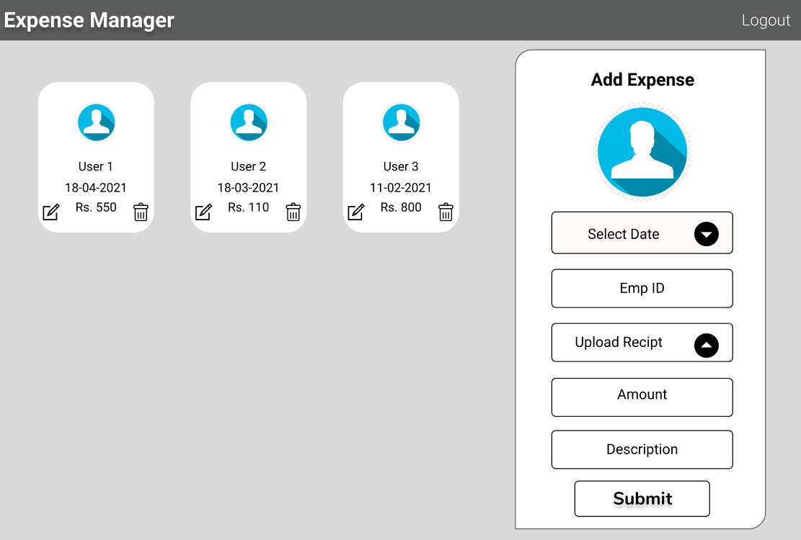
ADMIN:
HOME:
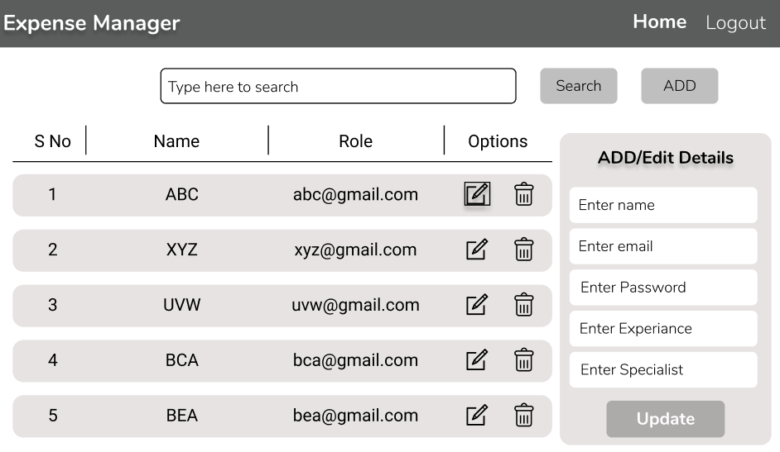

Backend:
Class and Method description:

Model Layer:

- UserModel: This class stores the user type (admin or the Manager or the Employee) and all user information.
  - Attributes:
    - email: String
    - password: String
    - username: String
    - mobileNumber: String
    - active: Boolean
    - role: String
  - Methods: -
- LoginModel: This class contains the email and password of the user.
  - Attributes:
    - email: String
    - password: String
  - Methods: -
- ExpenseModel: This class stores the details of the product.
  - Attributes:
    - expenceId: String
    - billNumber: Int
    - billImage: Blob
    - billCost: int
    - datedOn: Date
    - status: String
    - remark: String
    - claimedBy: UserModel
  - Methods: -
Controller Layer:
- SignupController: This class control the user signup
  - Attributes: -
  - Methods:
    - saveUser(UserModel user): This method helps to store users in the database and return true or false based on the database transaction.
- LoginController: This class controls the user login.
  - Attributes: -
  - Methods:
    - checkUser(LoginModel data): This method helps the user to sign up for the application and must return true or false
- ExpenceController: This class controls the add/edit/update/view Expense.
  - Attributes: -
  - Methods:
    - List<ExpenseModel> getExpense(): This method helps the admin to fetch all Expense from the database.
    - ExpenseModel expenseEditData(String id): This method helps to retrieve a Expense details from the database based on the Expense id.
    - expenseEditSave(ExpenseModel data): This method helps to edit a Expense details and save it to the database.
    - expenseSave(ExpenseModel data): This method helps to add a new product to the database.
    - expenseDelete (String id): This method helps to delete a Expense details from the database.
- MailController: This class helps in sending mail to the User.
  - Attributes: -
  - Methods:
    - sendMail(String id): This method helps to send the mail based on the status updated by the admin/ HR.

